Supporting Publication
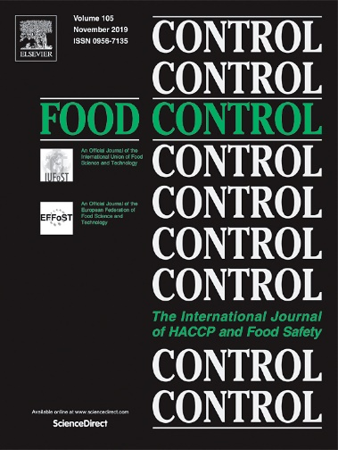
Food Control is an international journal that provides essential information for those involved in food safety and process control.
Food Control covers the below areas that relate to food process control or to food safety of human foods:
• Microbial food safety and antimicrobial systems
• Mycotoxins
• Hazard analysis, HACCP and food safety objectives
• Risk assessment, including microbial and chemical hazards
• Quality assurance
• Good manufacturing practices
• Food process systems design and control
• Food Packaging technology and materials in contact with foods
• Rapid methods of analysis and detection, including sensor technology
• Codes of practice, legislation and international harmonization
• Consumer issues
• Education, training and research needs.
The scope of Food Control is comprehensive and includes original research papers, authoritative reviews, short communications, comment articles that report on new developments in food control, and position papers.
The work described should be innovative either in the approach or in the methods used. The significance of the results either for the science community or for the food industry must also be specified. Contributions that do not fulfil these requirements will not be considered for review and publication.
For more information please visit: https://www.journals.elsevier.com/food-control

Call for papers
Special Issue from the EuroResidue IX conference
Food Control is inviting all oral and poster presenters at the EuroResidue IX Conference to submit papers on their presented work to the Special Issue of the journal.
Submissions for this Special Issue can be in the form of original research papers, review articles, and short communications. All submitted papers will be subjected to the same screening and peer-review process as regularly submitted papers.
The Journal's Guide for Authors on how to prepare a paper is available at https://www.elsevier.com/journals/food-control/0956-7135/guide-for-authors. Papers must be submitted electronically via the Editorial Manager System (EM) site for the Journal at https://www.editorialmanager.com/foodcont/default.aspx.
The submission portal will open on May 23, 2022 and will close on September 1, 2022. After this date, the portal will be closed.
To ensure that all manuscripts are correctly identified for inclusion into the special issue, it is important to select " VSI: ER IX - Vet Drug Residue" when you reach the "Article Type" step in the submission process.
Guest Editors:
Prof. Bruno Le Bizec
Dr. Aldert Bergwerff
Dr. Saskia Sterk
Dr. Leendert Van Ginkel
Any inquiries regarding the content of papers should be submitted to: Prof. Bruno Le Bizec bruno.lebizec@oniris-nantes.fr

